PURPOSIVE COMMUNICATION

**NAME : JUDAH PAULO LL. VIÑAS DATE : OCTOBER 12, 2022**

**COURSE&SECTION : BSIT-1F**

MODULE 3

Communication in Multicultural Contexts

**II. Warm-up**

For 2-3 minutes, write five terms/phrases you can connect with “Multiculturalism”

1. [Ethnicities](https://www.merriam-webster.com/dictionary/ethnicities)
2. Globalization
3. Culture
4. Mass Immigration
5. Races

**III. Self-Audit**

After completing the warm-up activity, tick the column that best describes your ability to communicate in the context of globalization. Answer the section as objectively as possible. Bear in mind that there are no wrong answers.

|  |  |  |  |  |
| --- | --- | --- | --- | --- |
|  | **Usually**  **(3)** | **Sometimes**  **(2)** | **Seldom**  **(1)** | **Never**  **(0)** |
| 1. I am culturally-sensitive, polite, tactful, and respectful in my written speech and non-verbal communication. | **✔** |  |  |  |
| 1. I avoid gender-biased language. | **✔** |  |  |  |
| 1. I communicate to share information across language cultures. |  | **✔** |  |  |
| 1. I don’t stereotype or generalize certain groups. |  | **✔** |  |  |
| 1. I listen attentively when others are speaking. | **✔** |  |  |  |
| 1. I observe physical space and distance. | **✔** |  |  |  |
| 1. I respect a person’s right to privacy and confidentiality. | **✔** |  |  |  |
| 1. I show consideration. | **✔** |  |  |  |
| 1. I show genuine interest in engaging and participating in local language and culture. |  | **✔** |  |  |
| 1. I make positive interpretations with the words and actions of other people. | **✔** |  |  |  |
| **TOTAL** | **21** | **6** | **0** | **0** |
| **GRAND TOTAL** | **27 - Advanced** | | | |

**VI. Task**

1. If you are a writer, write a short English poem about the topic (maximum of 3 stanzas).
2. If you are an artist, create a poster about the topic (any medium is allowed).

**POSTER**

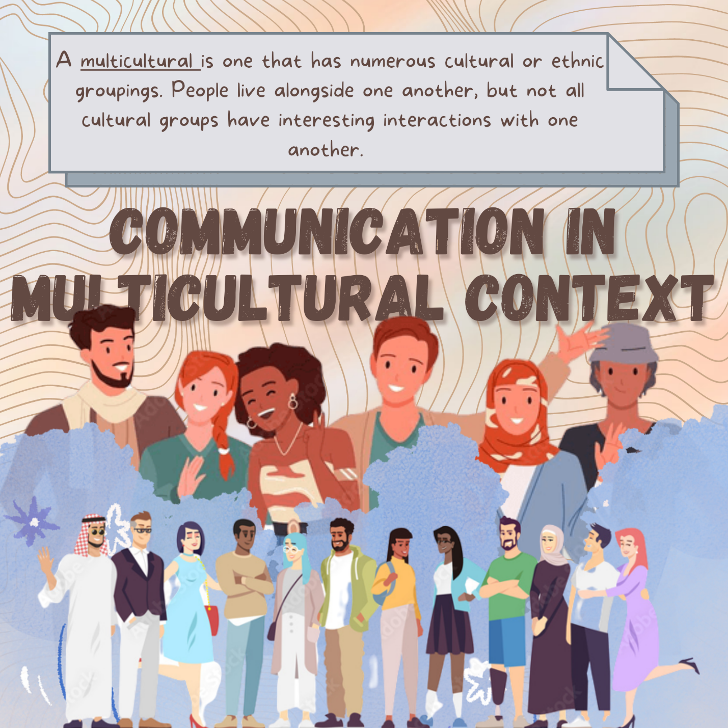(through Canva)

**VII. Reflection**

|  |  |
| --- | --- |
| **What were your misconceptions about the topic prior to taking up this lesson?** | **What new or additional learning have you gained from this lesson in terms of skills, content, and attitude.** |
| *I thought*… that we don’t have different communication strategies to communication on different culture. | *I learned that…* there is many strategies to communicate in different culture such as Intercultural Communication Skills, General Guidelines for Communicating in a Multicultural, Gender-Biased Words or Sexist Language and Ways to Avoid Gender-Biased Language. |